Practical 2
Aim : To Implement WordCount problem using Hadoop MapReduce in Eclips.
Step 1 : Run your cloudera system. Open Eclipse.
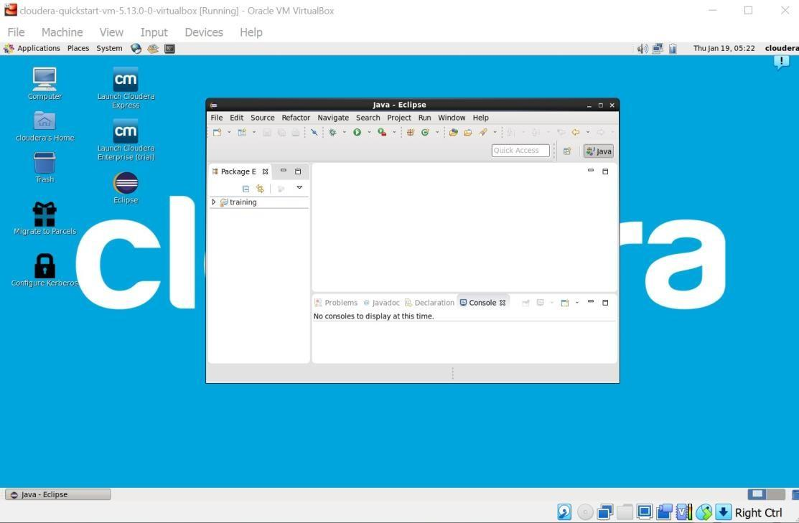
Step 2 : Click on File > New > java project. Give Project Name (“WordCount”).
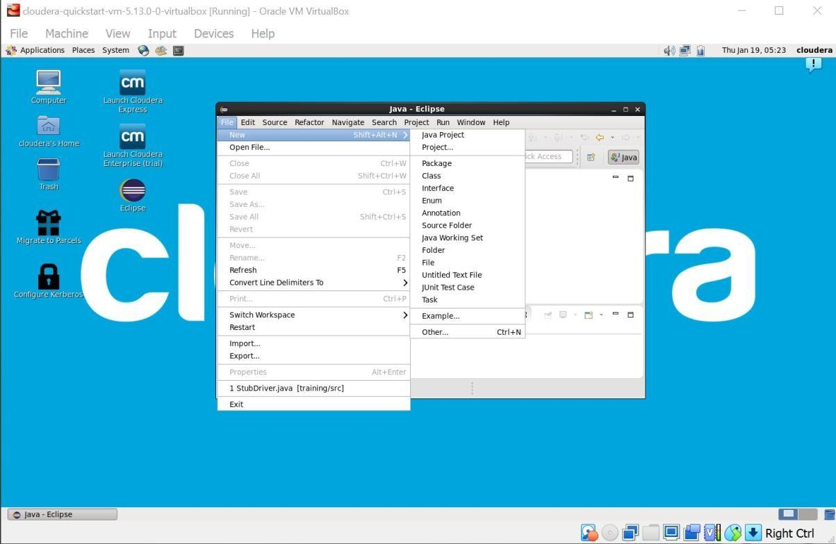

Step 3 : Click on Libraries tab. Then click on Add External JARs… Tab To add Hadoop Libraries.
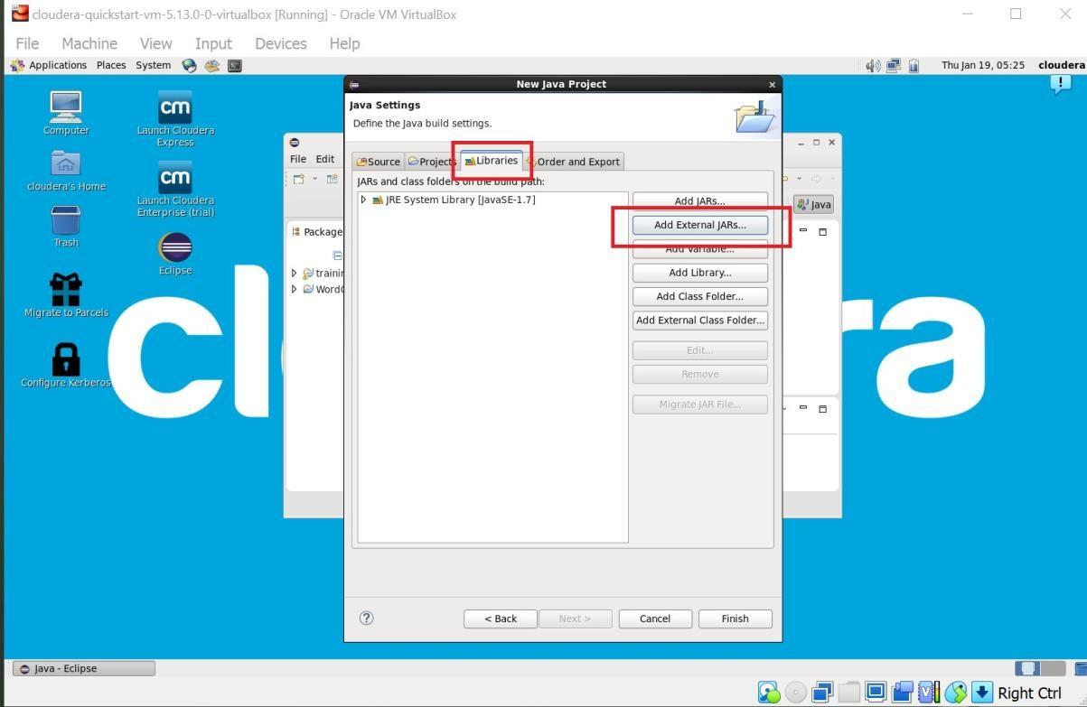

Step 4 : Follow this steps : Click on File System -> usr -> lib -> hadoop (Select all the libraries (JAR files) -> Click OK.
Again Click on Add External JARs… -> client -> select all jar files -> ok -> Finish.
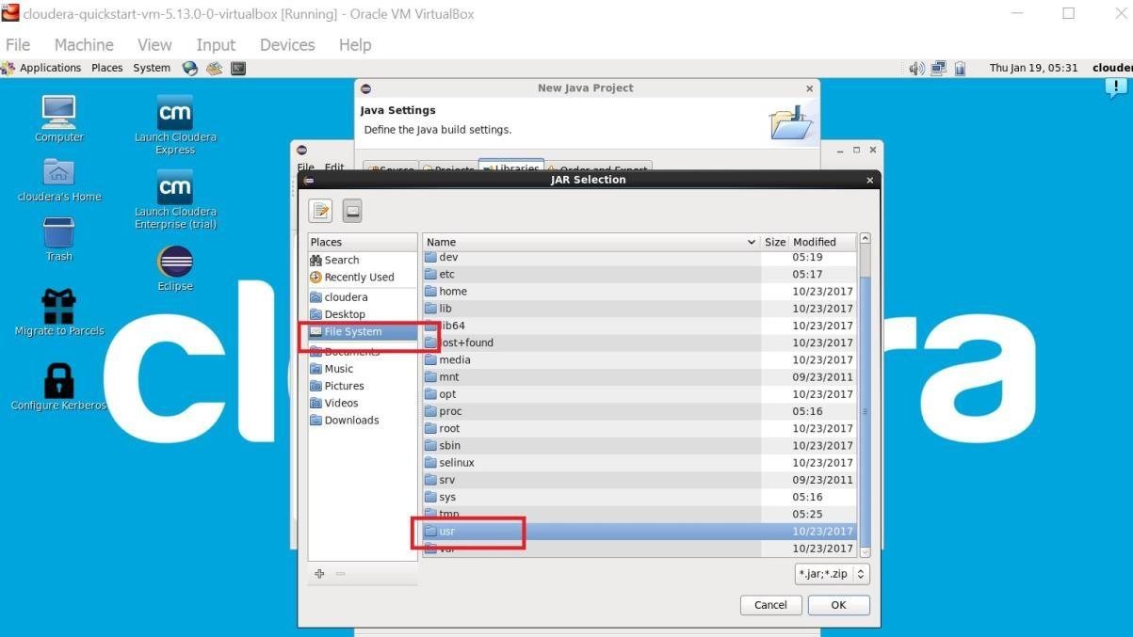

Step : 5
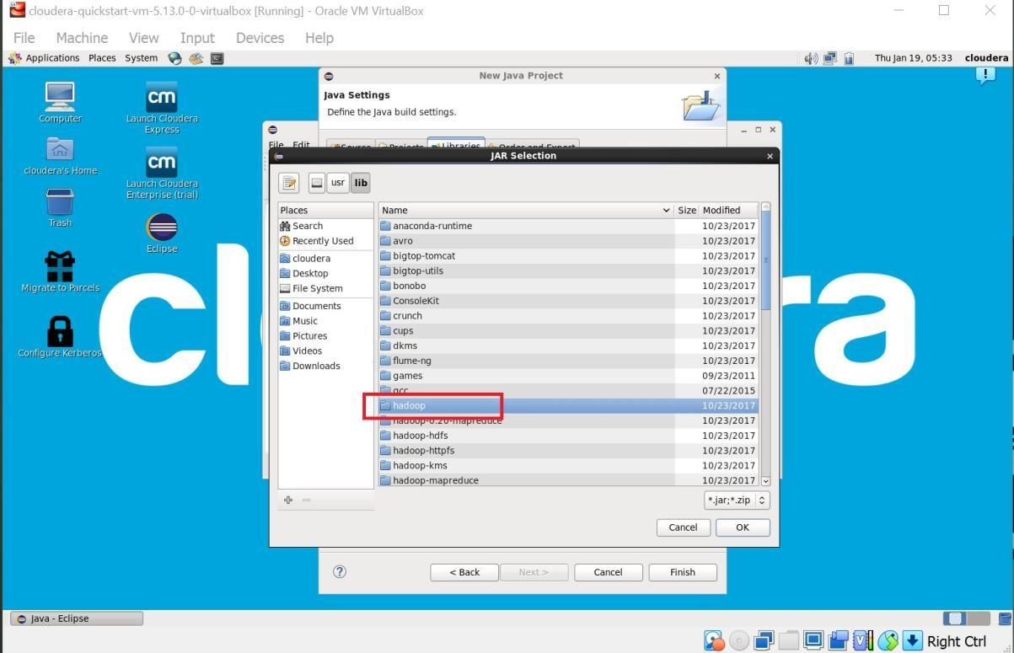

Step : 6
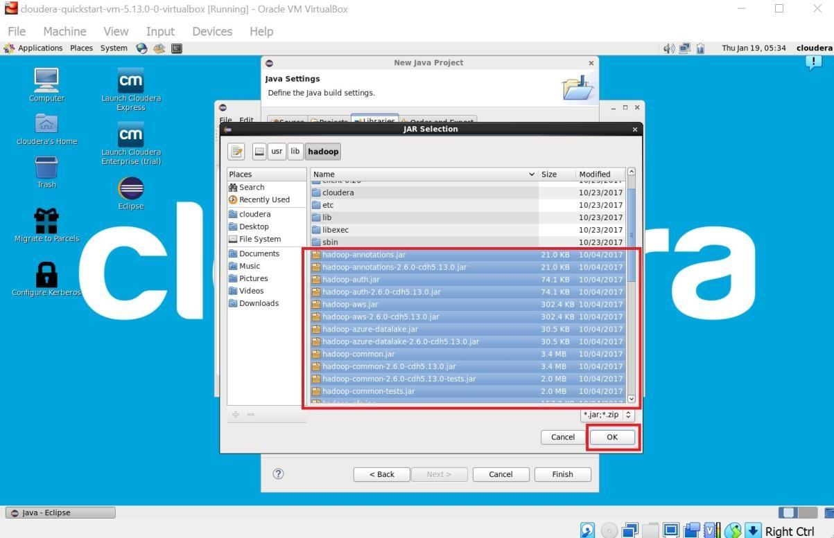

Step : 7
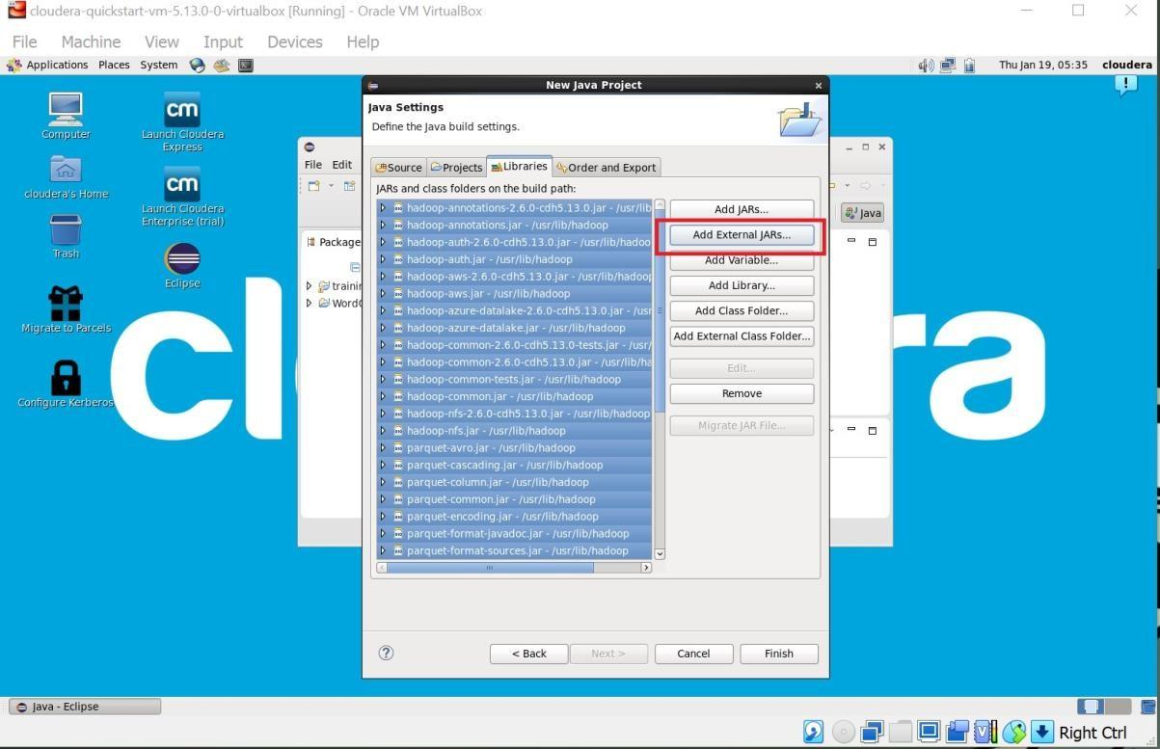

Step : 8
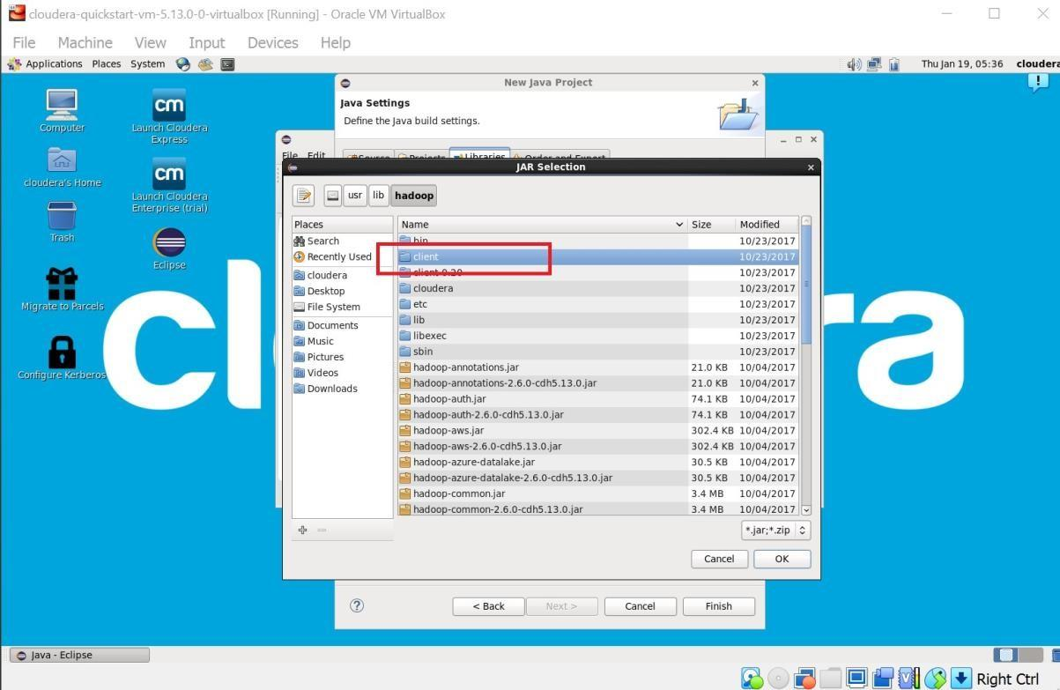

Step : 9
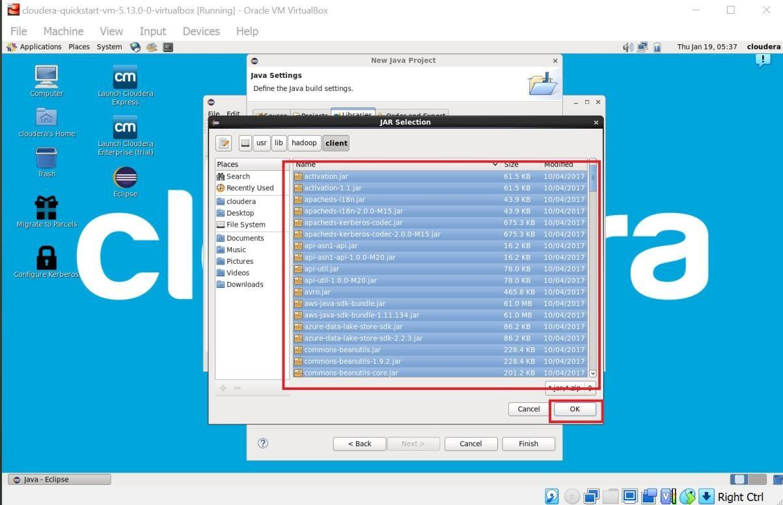

Step : 10
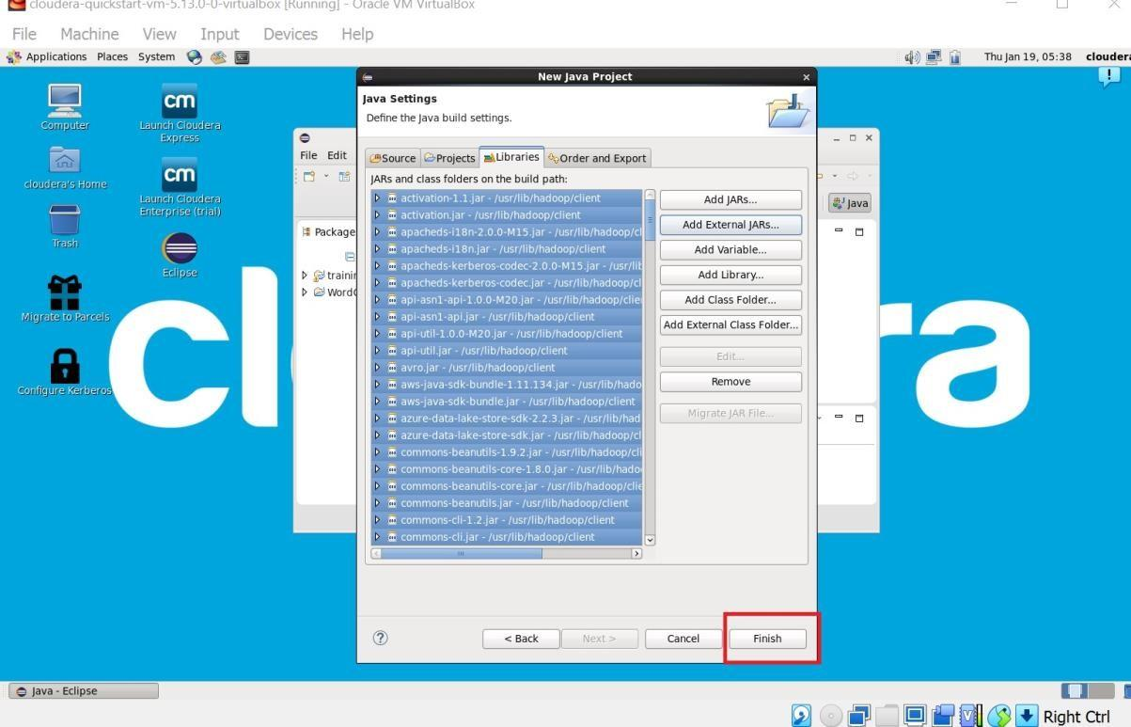

Step 11 : Now you will see project name “WordCount” on sidebar. Right Click on Project name “WordCount” -> New -> class.
For package write name “WordCloud” -> Finish.
WordCount.java window will pop up.

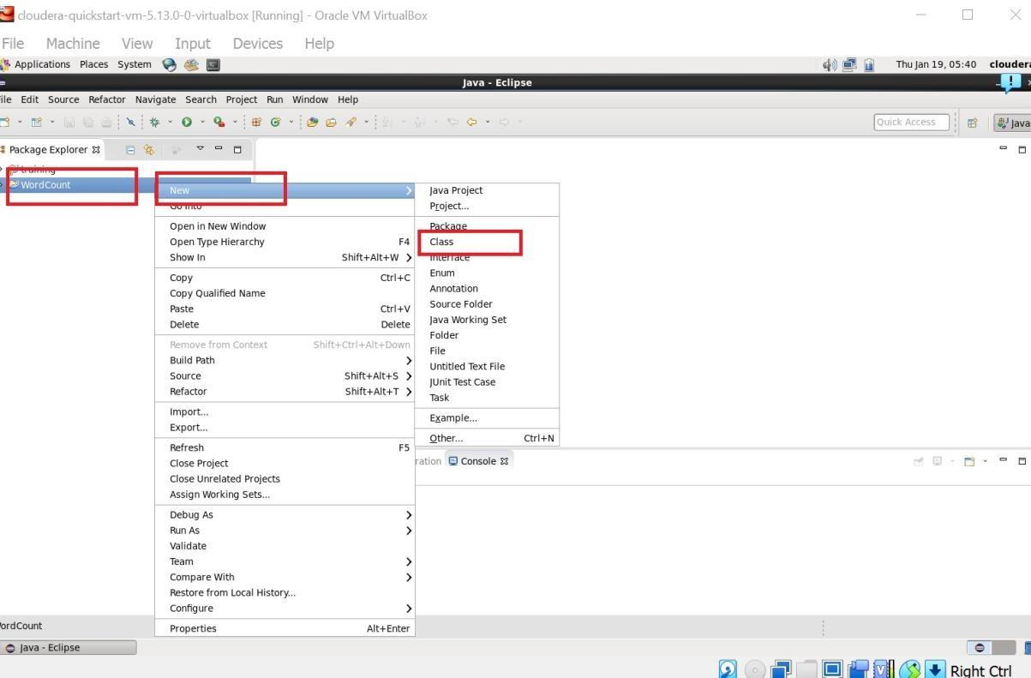

Step : 12 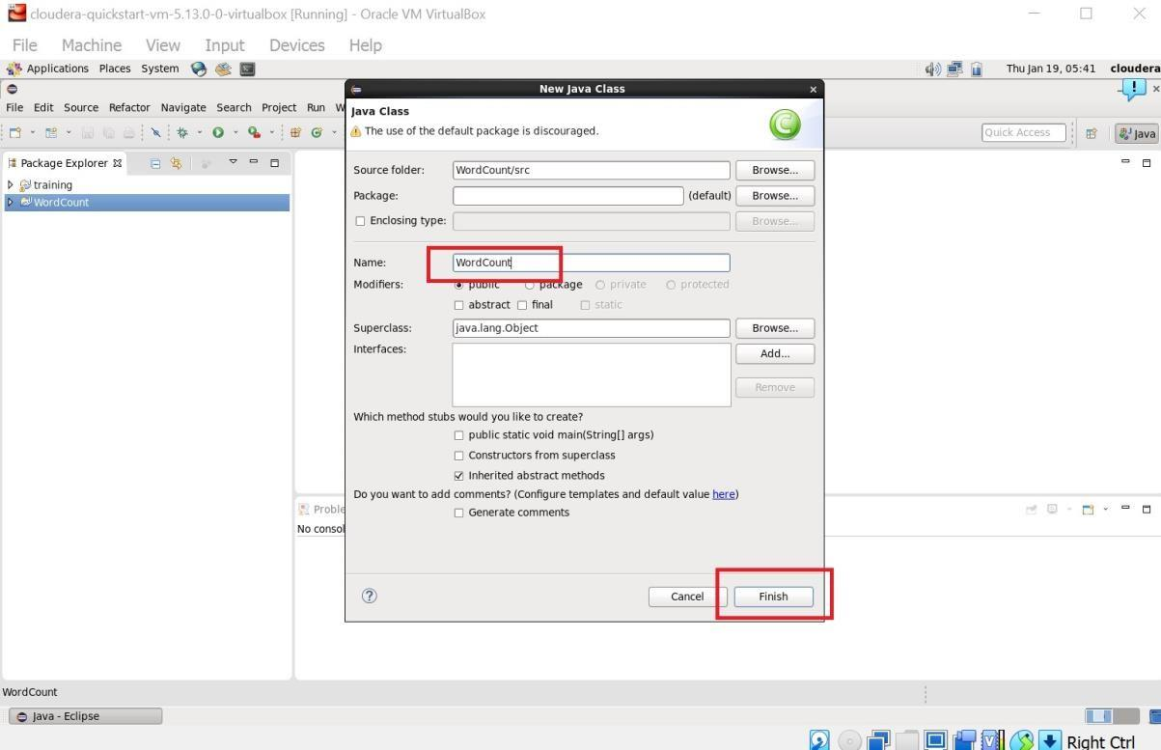

Step 13 : Write your code in window(WordCount.java).
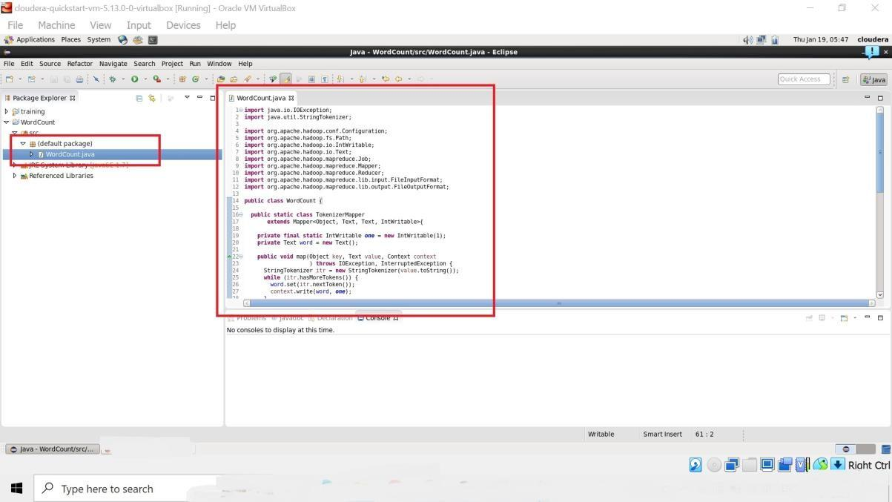

Step 14 : Right Click on the project name
WordCount -> Export -> Java -> JAR File -> Next -> For select the export destination for JAR file:
browse -> Name : WordCount.jar -> save in folder -> cloudera -> Finish -> OK
(** I used “WordCloud.jar” here)
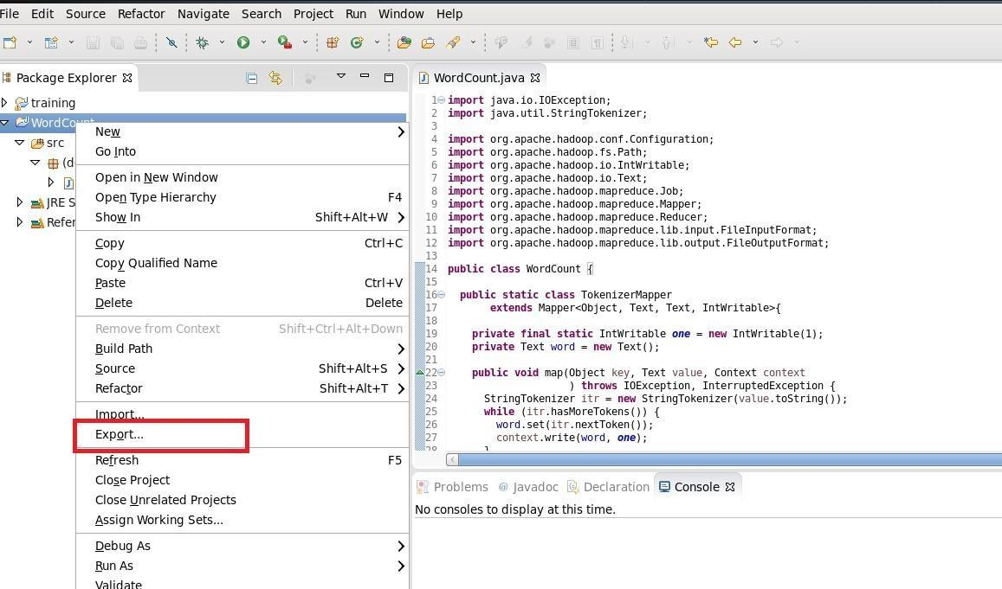

Step : 15
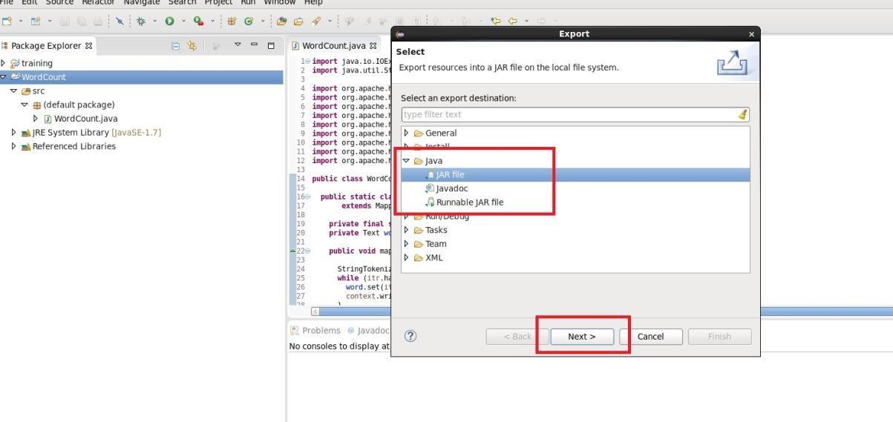

Step : 16
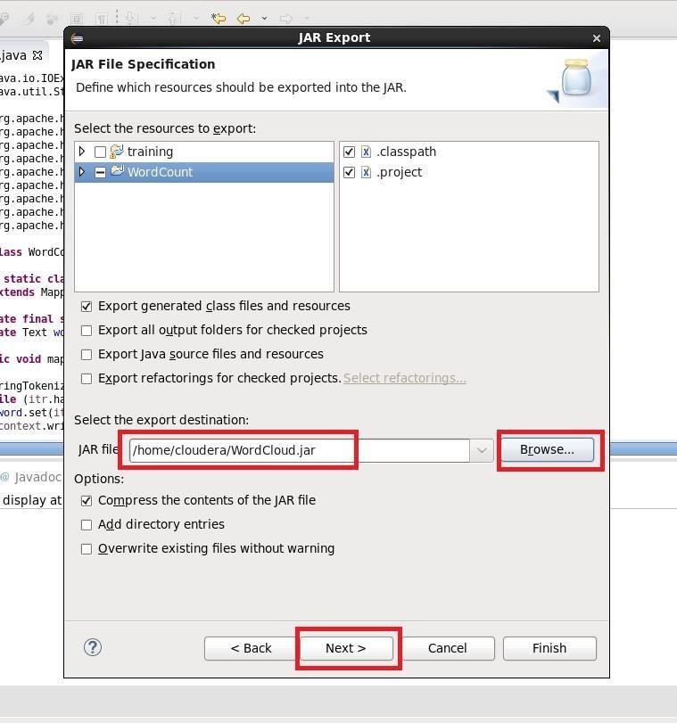
Step 17 : Now open terminal . follow this commands.
[cloudera@quickstart ~]$ ls cloudera-manager cm_api.py Desktop Documents Downloads eclipse enterprise-deployment.json expressdeployment.json kerberos lib
Music parcels Pictures Public Templates Videos WordCloud.jar Workspace
[cloudera@quickstart ~]$ pwd
/home/cloudera
[cloudera@quickstart ~]$ gedit abc.txt [cloudera@quickstart ~]$ cat abc.txt hi my name is Aman. my college name is R J College.
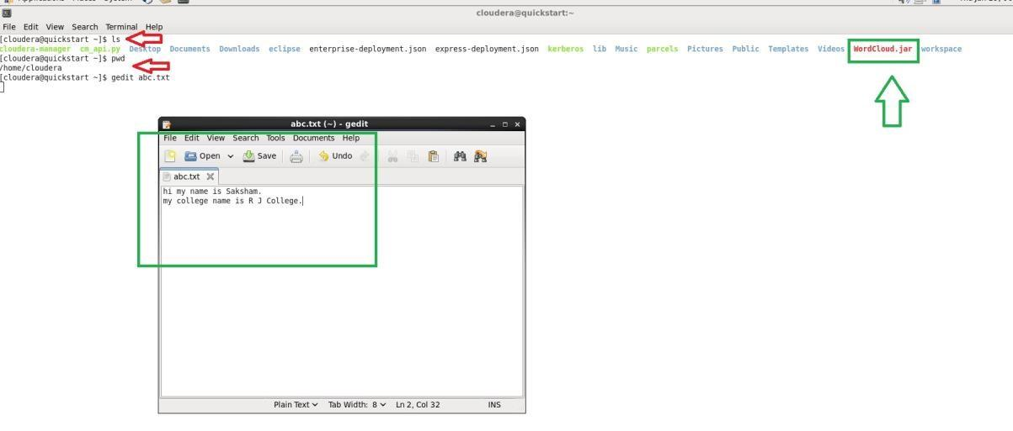
Step 18 :
[cloudera@quickstart ~]$ hdfs dfs -ls / Found 6 items drwxrwxrwx - hdfs supergroup 0 2017-10-23 09:15 /benchmarks drwxr-xr-x - hbase supergroup 0 2023-01-19 05:20 /hbase drwxr-xr-x - solr solr 0 2017-10-23 09:18 /solr drwxrwxrwt - hdfs supergroup
0 2023-01-19 05:20 /tmp drwxr-xr-x - hdfs supergroup 0 2017-
10-23 09:17 /user drwxr-xr-x - hdfs supergroup 0 2017-10-23 09:17 /var
[cloudera@quickstart ~]$ hdfs dfs -mkdir /inputdir
[cloudera@quickstart ~]$ hdfs dfs -ls / Found 7 items drwxrwxrwx - hdfs supergroup 0 2017-10-23 09:15 /benchmarks drwxr-xr-x - hbase supergroup 0 2023-01-19 05:20 /hbase drwxr-xr-x - cloudera
supergroup 0 2023-01-19 06:04 /inputdir drwxr-xr-x - solr solr
0 2017-10-23 09:18 /solr drwxrwxrwt - hdfs supergroup 0 2023-

01-19 05:20 /tmp drwxr-xr-x - hdfs supergroup 0 2017-10-23
09:17 /user drwxr-xr-x - hdfs supergroup 0 2017-10-23 09:17 /var
[cloudera@quickstart ~]$ hdfs dfs -put /home/cloudera/abc.txt /inputdir/
[cloudera@quickstart ~]$ hdfs dfs -ls /inputdir
Found 1 items
-rw-r--r-- 1 cloudera supergroup 55 2023-01-19 06:05 /inputdir/abc.txt
[cloudera@quickstart ~]$ hdfs dfs -cat /inputdir/abc.txt my name is Aman. my college name is R J College.
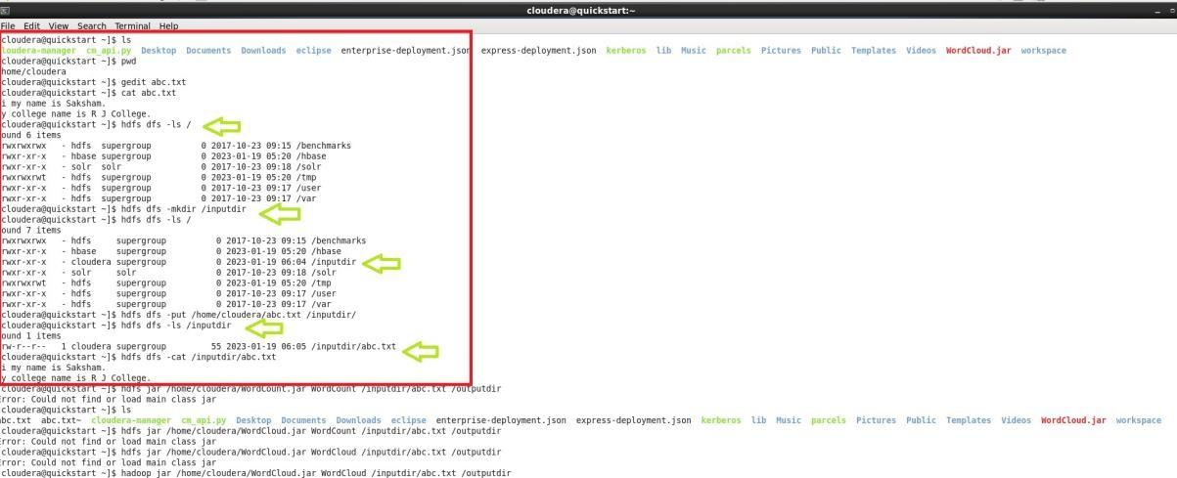

Step 19 :
[cloudera@quickstart ~]$ hadoop jar /home/cloudera/WordCloud.jar WordCount
/inputdir/abc.txt /outputdir It will Start executing the program
executing the program.
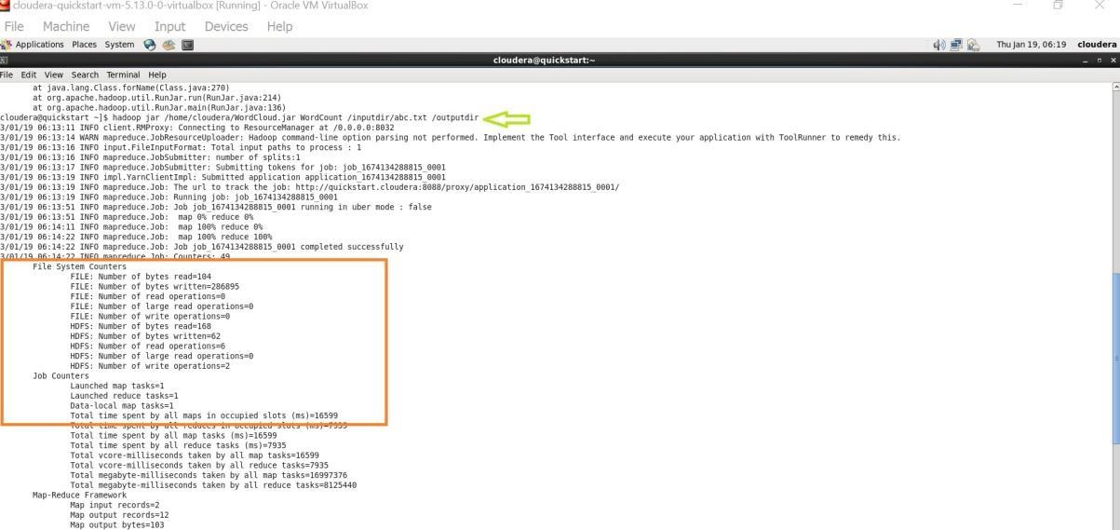

Step 20 :
[cloudera@quickstart ~]$ hdfs dfs -ls / Found 8 items drwxrwxrwx - hdfs supergroup 0 2017-10-23 09:15 /benchmarks drwxr-xr-x - hbase supergroup 0 2023-01-19 05:20 /hbase drwxr-xr-x - cloudera supergroup 0 2023-01-19 06:05 /inputdir drwxr-xr-x - cloudera
supergroup 0 2023-01-19 06:14 /outputdir drwxr-xr-x - solr solr
0 2017-10-23 09:18 /solr drwxrwxrwt - hdfs supergroup 0 2023-
01-19 05:20 /tmp drwxr-xr-x - hdfs supergroup 0 2017-10-23
09:17 /user drwxr-xr-x - hdfs supergroup 0 2017-10-23 09:17 /var
[cloudera@quickstart ~]$ hdfs dfs -ls /outputdir
Found 2 items
-rw-r--r-- 1 cloudera supergroup 0 2023-01-19 06:14 /outputdir/_SUCCESS -rw-r-r-- 1 cloudera supergroup 62 2023-01-19 06:14 /outputdir/part-r-00000

Final Output :
[cloudera@quickstart ~]$ hdfs dfs -cat /outputdir/part-r-00000
College. 1
J 1
R 1
Aman. 1 college 1 hi 1 is 2 my 2 name 2

[cloudera@quickstart ~]$
